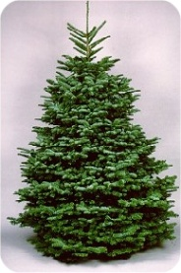
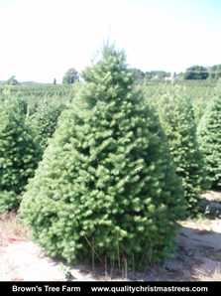
Customer Name:
Phone Number:
Email:

Douglas Fir
Christmas Tree Order Form

Noble |  |  |  |  | Douglas |  |  |  | Decorated  Wreath |  | Garland
5-6  $52 | 6-7  $62 | 7-8  $78 | 8-9  $114 | 9-10  $158 | 5-6  $40 | 6-7  $46 | 7-8  $52 | 8-9  $72 | Small  $25 | Large  $30 | $2.75 ft. | Total

Noble Fir

Send Order to:
Email to: life@casadevida.net
Fax to: 805.986.2801

